Docs Not Cops Toolkits – How to Guide
We have produced toolkits designed to be used to support people in starting a campaign in their local area, and to provide resources for the continued development of campaigns once they have started.

Toolkit 1
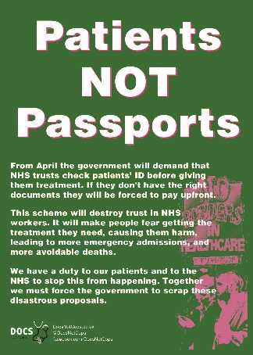
This kit contains a flyer and a poster. The flyer is designed to inform people about the campaign and point them to the docs not cops website for more info. The poster is designed to be used to publicise your own meeting and has a space for you to enter your own details.
The flyer is designed in full colour, if you would like to print some then let us know and we can send you the full colour designs. For ease of printing the toolkit contains 2 versions of the flyer, one in colour with a white background and one in black and white. It is designed to be printed double sided
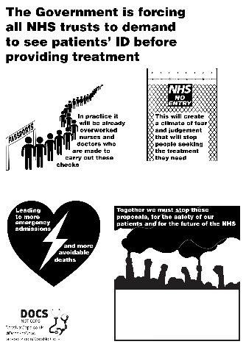
The poster is designed only in black and white for easy printing anywhere (even at work!). It comes as a word document so you can add your own meeting date, time and location.
Toolkit 2
This kit contains a selection of additional resources that will hopefully support your campaign as it grows. It contains:
- What is the Immigration Act?
- Arguments against charging in healthcare
- Guide to accessing GP services
- GP surgery poster.

